Finadel SRS

* Normal Signup (Register) and sign in
* Responsive Website
* After Costumer login All shops should be visible

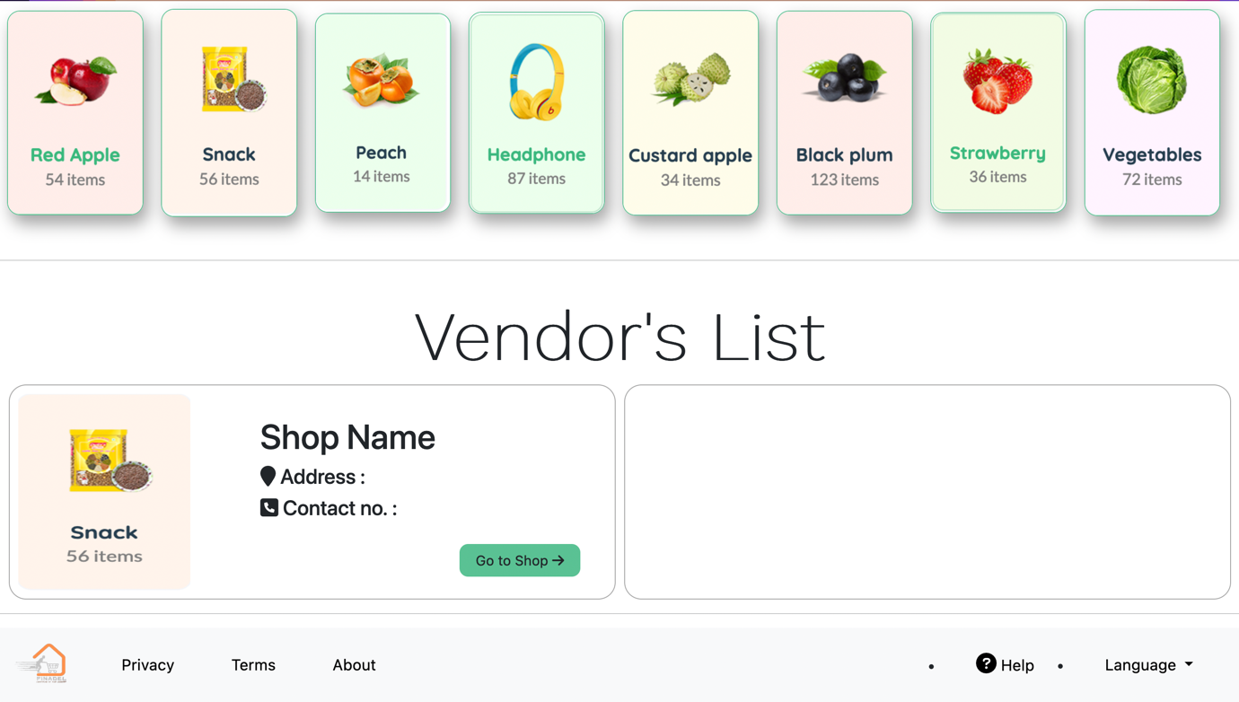

We can click on any shop and order any thing

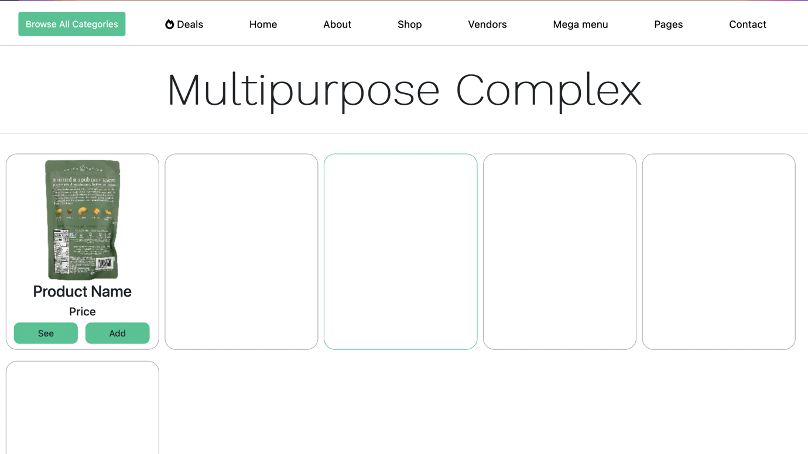

All the items should be added to (Cart)

After selecting all items we can order by checking our cart

* Shopkeeper Portal

In this portal , Shopkeeper can add items

Can Check If someone have ordered something ( Their location also )

Shopkeeper can also update the availability of each and every item

* Admin Portal

Should be having Details of all Shopkeepers their location their shop name and location

And Details of all Users their location , phone no.

All these details in tabular form only

For Any UI/UX related query take refrence from :-

http://preview.themeforest.net/item/nest-multipurpose-ecommerce-html-template/full_screen_preview/33948410?_ga=2.249458447.902058357.1660923240-1876894461.1655209648